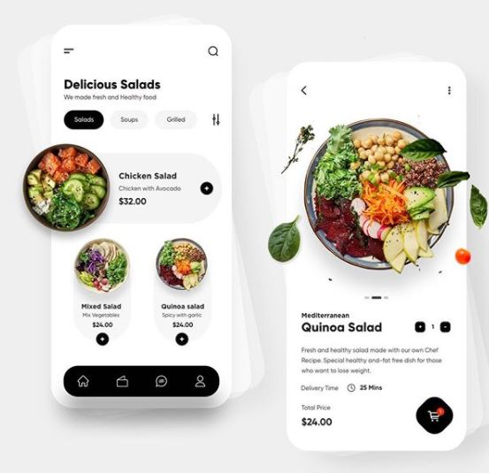

Color de fondo: #FFFFFF

#343434



#050505

#5F5F5F

 #030303

 #A0A0A0

#F5F5F5

 #808080

#393939

 #050505

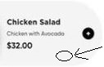

#F4F4F4

#333333

#9F9F9F

#151515



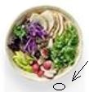 #DBDCDC

 #010101

#9E9E9E



 #B8B8B8

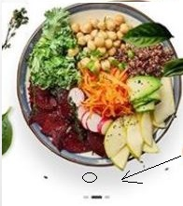 #DADADA

#313131  
 #C3C3C3

#2A2A2A

 #151515

#050505

 #848484

 #575757

 #8E8E8E

#131313

#010101

 #D92C14

Carrito= #F4F3F4